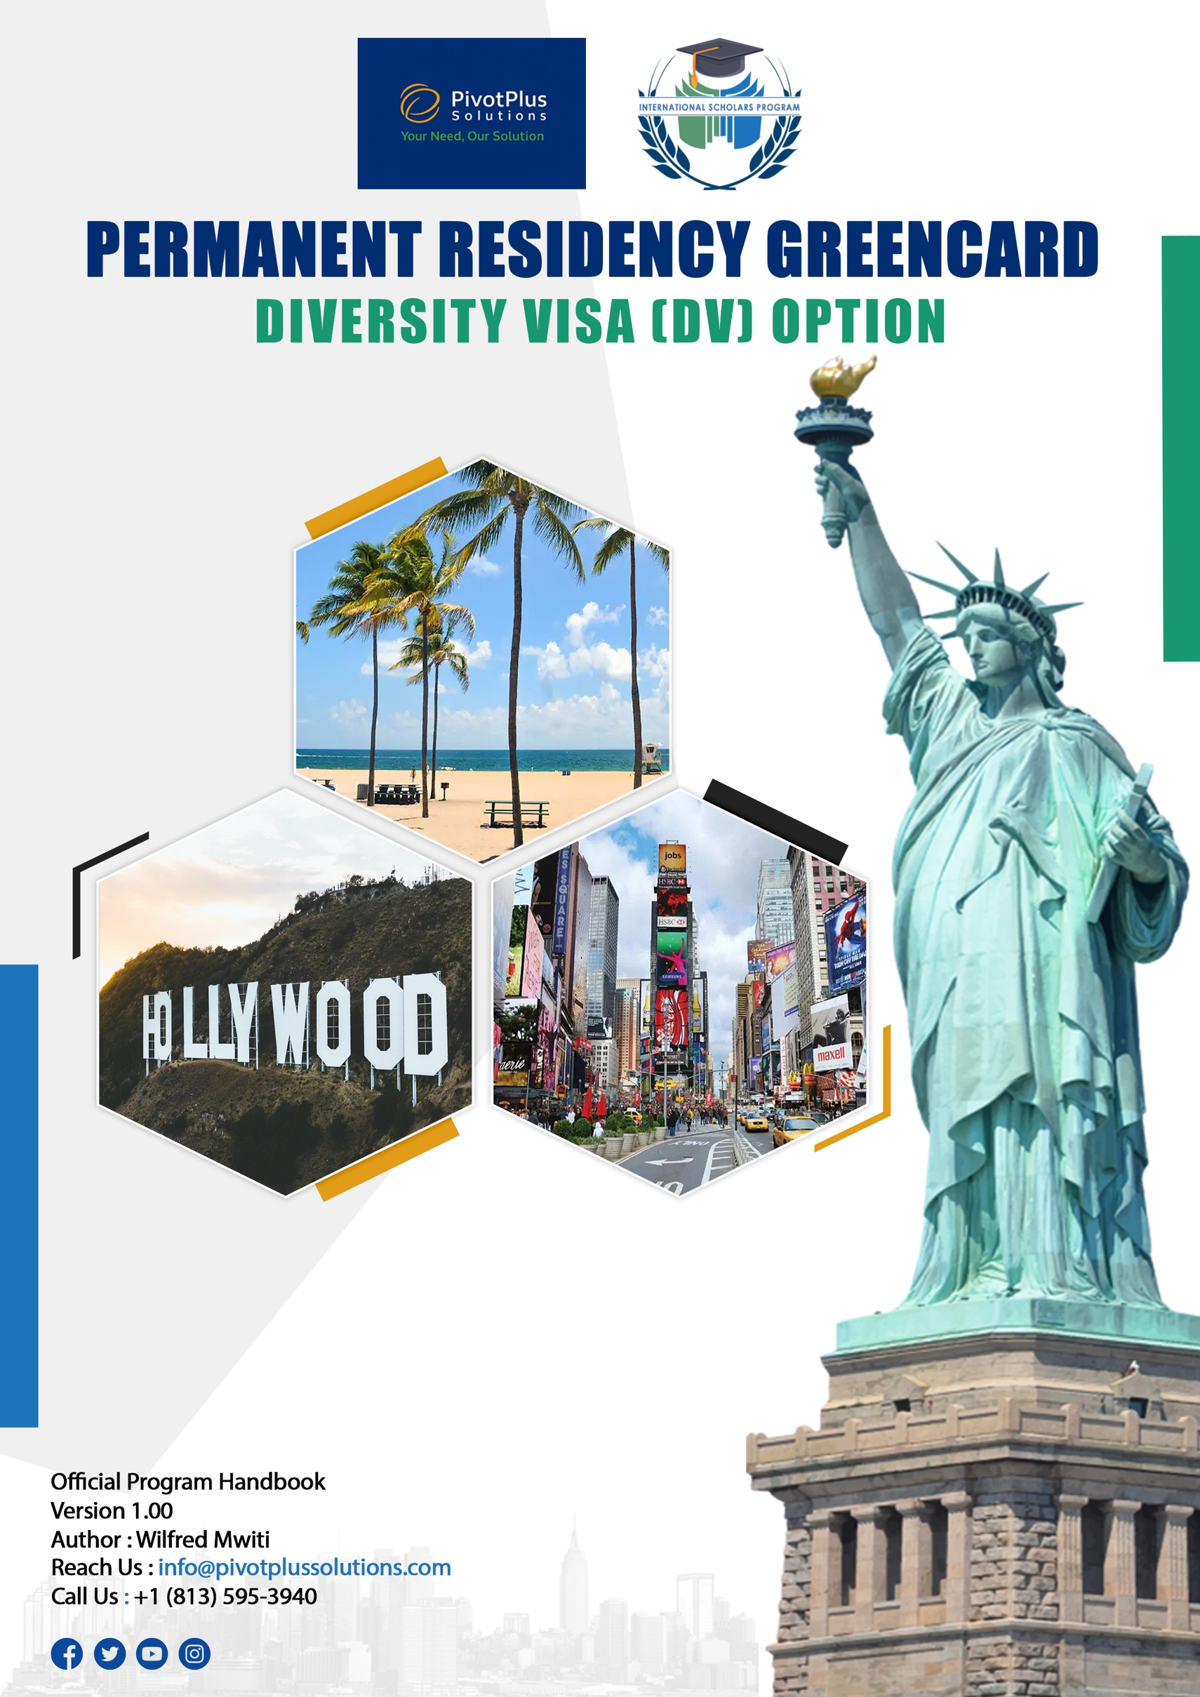


Contents
OVERVIEW 2
Applying for the Permanent Residency Greencard (DV Lottery) 2
Meeting relocation and settlement costs 2
Providing hosting support 3
Finding reliable jobs 3
Transport means 3
Advising on schooling for kids 3
Providing financial mentorship 4
HOW THE PROGRAM WORKS 4
ACADEMIC QUALIFICATION REQUIREMENTS 4
ENROLMENT STEPS 4
STEP 1: Apply for the program 4
STEP 2: Making your registration payment. 4
STEP 3: Applying for the green card lottery 4
Step 4: Application status check 4
STEP 5: Job skills training programs 4
STEP 5: Visa application (Filling DS 260) and coaching 5
STEP 6: Meeting medical requirements 5
STEP 7: Relocation to the US 5
STEP 9: Finding reliable jobs and transport means 5
PROGRAM’S RELOCATION KITTY 6
CONTRIBUTION PACKAGE OPTIONS: 6
PERMANENT RESIDENCY GREENCARD (DV LOTTERY) RELOCATION BUDGET 7
WHY TAMPA, FLORIDA AS THE RELOCATION DESTINATION 8
Ideal Weather Throughout the Year 8
Best Sandy Beaches in the World 9
Great Attractions 10
Reasonable Cost of Living 11
No State Income Taxes 12
Top Notch Schools 13
A Growing Community of Kenyan Professionals 14
OUR LOCATION AND CONTACT DETAILS 14

OVERVIEW
Every year, the United States of America (USA) issues up to 55,000 diversity visas or green cards to eligible immigrants from across the world. Out of this number, around 5,000 Kenyans win the lottery annually. Usually, the visas are given to those having at least a high school education qualification. Successful applicants normally help bridge the gap between labor supply and labor demand in skilled and semi-skilled jobs in the US.
The Permanent Residency Greencard (DV Lottery) Program seeks to help qualified Kenyans navigate through the intricacies surrounding the whole process right from applying for green card lottery to smooth settling in the US. We offer indispensable guidance to thousands ready to take a reap of faith in trying their lottery luck in pursuit of the American dream.
For this matter, the program seeks to solve these challenges that Kenyans face in actualizing their dreams through a green card lottery:
- Applying for the green card lottery.
- Meeting relocation and settlement costs.
- Hosting support.
- Finding reliable good jobs.
- Advising on schooling for kids.
- Transport means support.
- Financial mentorship

Applying for the Permanent Residency Greencard (DV Lottery)
In many cases, most green card lottery applications are normally rejected because of applicants’ inability to adhere to specific tenets, which guide the entire process. Essentially, lack of adequate information and misinformation remain some of the greatest impediments to successful green card lottery application.
Understanding this challenge, this program is designed to make the application process as seamless as possible. For this matter, we offer professional green card lottery application services, such as professional photography, which includes taking the right lottery photos for those within Nairobi. Anyone outside Nairobi is required to send us photos meeting certain criterion for the application. In addition, we usually facilitate passport expedite with the Directorate of Immigration Services for those without the document. The end to the game is making and submitting a DV Lottery application meeting the right standards for consideration.

Meeting relocation and settlement costs
Usually, being approved for the green card lottery is always a big deal. It is always the first step towards chasing the American Dream. However, in the words of Nelson Mandela, “when you climb on big hill, you find many others to climb.” In the context of these words, winning the green card lottery is on many occasions the beginning of another arduous journey. The most daunting challenge for many people is usually the question of how to meet various costs associated with the process right from the time they receive a confirmation that their entry is successful to the time of setting feet in the US. In fact, due to financial constraints, many Kenyans are unable to relocate to the US even after their green card applications are qualified.
It is against this background that this program comes in handy to help candidates win, in meeting various costs associated with the entire process. Some of these costs include but are not limited

to green card visa processing expenses, medical costs, flight tickets, accommodation for the first two months in the US, purchasing a car after settling in the US, and meeting other living expenses.

Providing hosting support
One of the greatest and among the most conspicuous challenges inclined to relocating to the US on a green card lottery is getting a host to temporarily house you as you settle in the US. As a requirement, before the US embassy approves your DV visa, you are required to explicitly provide the address of the place that you would be staying in the US. Generally, there are no limitations on who can serve as your host as long as they are legally in the US.
However, the process of finding a host is usually a nightmare to many due to a constellation of factors. For instance, many Kenyans don’t know anyone in the US. In addition, many people might be unwilling to host you due to their own personal reasons. Stories of potential hosts jumping ships and cutting off communication at the last hours are rife among many who come to the US under green card lottery. In even worser cases, some hosts resort to not picking you at the airport upon arrival and stranded, you find yourself submerged into an overly ugly situation in a strange new land. Underscoring the magnitude of this challenge, our program seeks to provide hosting to those relocating on green card lottery and support them until they have gained some stability.

Finding reliable jobs
Upon relocating to the US, life can be quite difficult without any source of livelihood. Paying for your bills, living a decent life worthy of someone in a first world country, and managing expectations back home in terms of financial needs, can be an expensive affair. Without a concrete plan, one can easily regret relocating. Generally, the first and the most basic step to curbing these challenges is by getting a job. Nevertheless, proper guidance is quite fundamental in getting good jobs where earnings are handsome. It is worth noting that not all jobs in the US pay well but with the right information, it can be quite easy getting placements in good and reliable jobs. Our program is founded on this ground to ensure that those who relocate are able to get jobs and work in fields that pay well.

Transport means
In the US, the public transport system isn’t popularly used like the situation in Kenya. Statistically, more than 90% of households in the US own cars. As a result, dependence on public transport can be both unsustainable inconveniencing. A car is like a basic need in the US and owning one typically forms an integral part of life. Essentially, it is a requirement to train again as a driver regardless of whether one used to drive in Kenya before. For this matter, our program is founded on the need to train those who relocate on how to drive on US roads and subsequently help them in acquiring driving licenses. More importantly, apprehending the obstacles that come with having no car, the program assists those who relocate in the process of purchasing cars by providing finances on the same.

Advising on schooling for kids
Settling in the US with your family on a green card requires a great deal of figuring out things, especially if your children are school going. Transitioning from the Kenyan education system to the US system can be a mountain of a challenge to many, particularly if someone doesn’t have sufficient information on some of the schools to consider for their children and the requirements for enrollment. Our program is your perfect guide to getting the right schools for your children and information on what is required before your kids are successfully inducted into the American education system.

Providing financial mentorship
The pursuit of the American dream is strongly hinged on a strong desire by people to turn their lives around, transform their families, and impact society positively. Real transformation is conventionally a product of prudent financial management. Without the right mindset and guidance, it is possible to reverse your own progress even after grabbing a rare opportunity of being in the US. To entrench constructive financial progress, our program offers financial mentorship to those who relocate to instigate growth across all spheres.

HOW THE PROGRAM WORKS

ACADEMIC QUALIFICATION REQUIREMENTS
To enroll in this Green card lottery option of our Permanent Residents Program, a minimum grade of C- and above in KCSE, is required. If you are submitting as a family, one of the spouses must have this minimum qualification.

ENROLMENT STEPS

STEP 1: Apply for the program.
- Visit our website and submit your application. You will receive a decision on acceptance into the program from our team within 48 hours.

STEP 2: Making your registration payment.
- After getting the acceptance confirmation email, you are required to make the following payments:
  - Qualified candidates should register with 30 USD to become part of the Green card
lottery option of our Permanent Residents Program for the specific year of application.

STEP 3: Applying for the Permanent Residency Greencard (DV Lottery).
- After making the payment, our team of experts will guide you on the next steps of applying for the lottery.

Step 4: Application status check
- Around May of every year when decisions are made by the US government regarding green card lottery applications, we check the status of the applications for those in the program to know whether their entries have been accepted.

STEP 5: Job skills training programs
- After you win the lottery, we shall enroll you into our lucrative job training programs in readiness for well-paying jobs in the American corporate space. Anyone who possesses a degree will be inducted into our tech training and anyone without a degree will be guided on other available job training that fits their career goals.

STEP 5: Visa application (Filling DS 260) and coaching
- If lucky, once you have won the lottery, we shall guide you through the entire visa application process and train you on how to ace the interview. We shall help you cover the visa processing costs.

STEP 6: Meeting medical requirements
- Once your visa application is completed, we then guide you through the process of meeting medical requirements laid down by the US government before the visa interview. We also help you cover the costs attached to this stage.

STEP 7: Relocation to the US
- Once your visa is approved, we will start the process of relocating you to the USA, specifically Tampa, Florida. Through the program, you will get assistance in meeting the costs associated with this stage, such as air ticket expenses and accommodation.

STEP 9: Finding reliable jobs and transport means.
- Once you relocate, we shall help you in finding jobs in areas within your scope of knowledge. To make your commuting easy, we shall offer you financial assistance and guidance in purchasing a car.

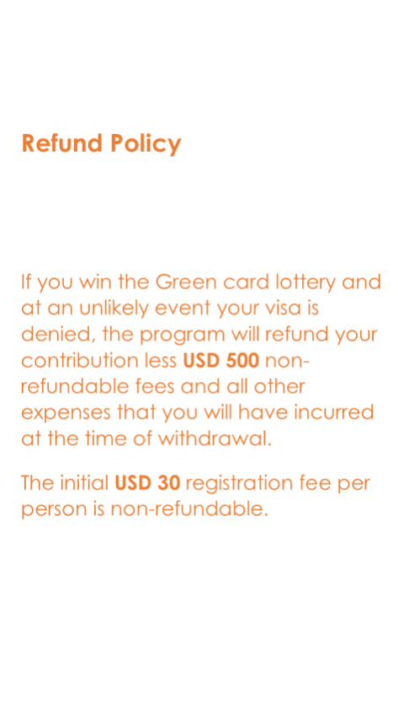
PROGRAM’S RELOCATION KITTY
- The program’s kitty plays a critical role in the initial financing of the relocation process.

- We acknowledge that the relocation process is an expensive affair hence the need for a source of funding for the beneficiary’s relocation expenses.

- Once you have won the lottery, you are required to choose from one of the 4 packages available and the contributions in 2-installments using our online system.

- There is a USD 50 late fee per month for any late payment of your contribution.

- The kitty will advance to you the amount as per chosen package to take care of all the relocation expenses to the USA plus other living expenses.

- The interest charged on the loan will be 1% per month on a reducing balance.

- You will start repaying the relocation loan 6 months after relocation. The loan repayment period is 24 months.

- You cannot change the package once you have enrolled, so you must carefully choose the best package that fits your needs.

CONTRIBUTION PACKAGE OPTIONS:

Refund Policy

If you win the Green card lottery and at an unlikely event your visa is denied, the program will refund your contribution less USD 500 non- refundable fees and all other expenses that you will have incurred at the time of withdrawal.
The initial USD 20 registration fee per person is non-refundable.

PACKAGE | NUMBER | CONTRIBUTION AMOUNT | MONTHLY INSTALMENT | LOAN AMOUNT
Bronze | 1 Person | $3,000 | $1,500 | $10,000
Silver | Couple (2 people) | $4,000 | $2,000 | $12,000
Gold | Couple+1 kid | $6,000 | $3,000 | $16,000
Platinum | Couple+More than 1 kid | $8,000 | $4,000 | $20,000

* The different package options determine your level of liquidity when you arrive in the US*

The Bronze package covers expenses for ONE INDIVIDUAL. These expenses include visa fees, medical expenses, flight tickets, accommodation, and upkeep for the first two months after relocating, and car purchase costs.

The Silver package covers expenses for a COUPLE (TWO PEOPLE) relocating together. These expenses include visa fees, medical expenses, flight tickets, accommodation, and upkeep for the first two months after relocating, and car purchase costs.

The Gold package covers expenses for a COUPLE AND ONE KID relocating together. These expenses include visa fees, medical expenses, flight tickets, accommodation, and upkeep for the first two months after relocating, and car purchase costs.

The Platinum package covers expenses for a COUPLE AND MORE THAN 1 KID relocating together. These expenses include visa fees, medical expenses, flight tickets, accommodation, and upkeep for the first two months after relocating, and car purchase costs.

PERMANENT RESIDENCY GREENCARD (DV LOTTERY) RELOCATION BUDGET

Installment payment | 2 equal monthly installments
Minimum KCSE requirement | C+ and above (if applying as a family one of the parents must meet this requirement)
Non-refundable fees | $500
Total relocation budget | All costs are borne by the kitty as a loan
 | Bronze | Silver | Gold | Platinum
Medical expenses | 500 | 1000 | 1500 | 2000
Visa fees | 200 | 400 | 600 | 800
Upkeep for the first two months in the USA | 1100 | 2100 | 3100 | 3700
Rent for the first two months in the USA | 2400 | 2400 | 2400 | 3800
Lease accommodation deposit | 500 | 500 | 500 | 500
Air ticket | 1300 | 2600 | 3900 | 5200
Car purchase (up to $3000) | 3000 | 3000 | 3000 | 3000
Consultation fees | 1000 | 1000 | 1000 | 1000
TOTAL | 10,000 | 13,000 | 16,000 | 20,000

WHY TAMPA, FLORIDA AS THE RELOCATION DESTINATION

Ideal Weather Throughout the Year
Tampa is at the heart of a rare gem, the Sunshine State, as Florida is popularly known. Just as the name suggests, unlike many other states in the US whereby temperatures can become
extremely cold, Florida’s climate is mostly tropical and subtropical and as a result, there is rarely any snowing. In fact, Florida’s climate is closely correlated with the climatic conditions in Kenya where snowing is an isolated occurrence, and the weather conditions are mostly warm throughout the year. Due to this fact, the state would be the most ideal climatically for someone moving from Kenya.


Best Sandy Beaches in the World
Are you a beach lover? Guess to your answer is a big yes. The fun and pomp of the beach life clearly define the life around the Tampa Bay area. Tampa is a vibrant tourist economy with many people visiting the city due to its endowment with some of the best beaches in the world. The Clear Water beach and St Pete beach, for instance, have been voted as among the world’s finest!
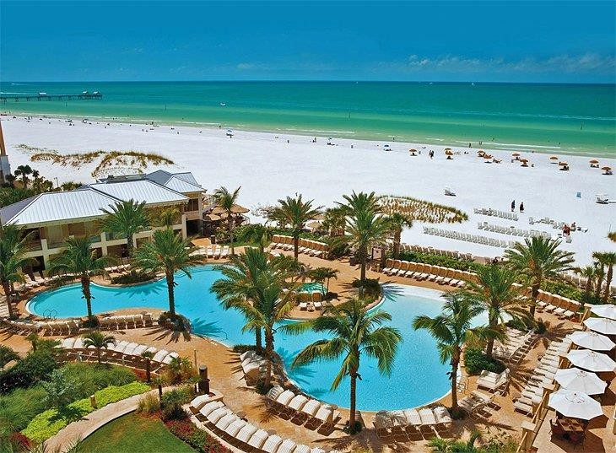

Great Attractions
The allures of Tampa are not just the sandy beaches. The Big Guava, as the city is popularly nicknamed has a constellation of other attractions with an unmatchable appeal. Tampa is home to the Busch Gardens Tampa Bay, Adventure Island, beautiful parks, ZooTampa at Lowry Park, and the Florida Aquarium, among others. Tampa also has a wide range of fun activities such as jet skiing, sky diving, go-karting, fishing, and zip-lining, the list is endless. Close to Tampa is Orlando, the home of Walt Disney and Disney World.
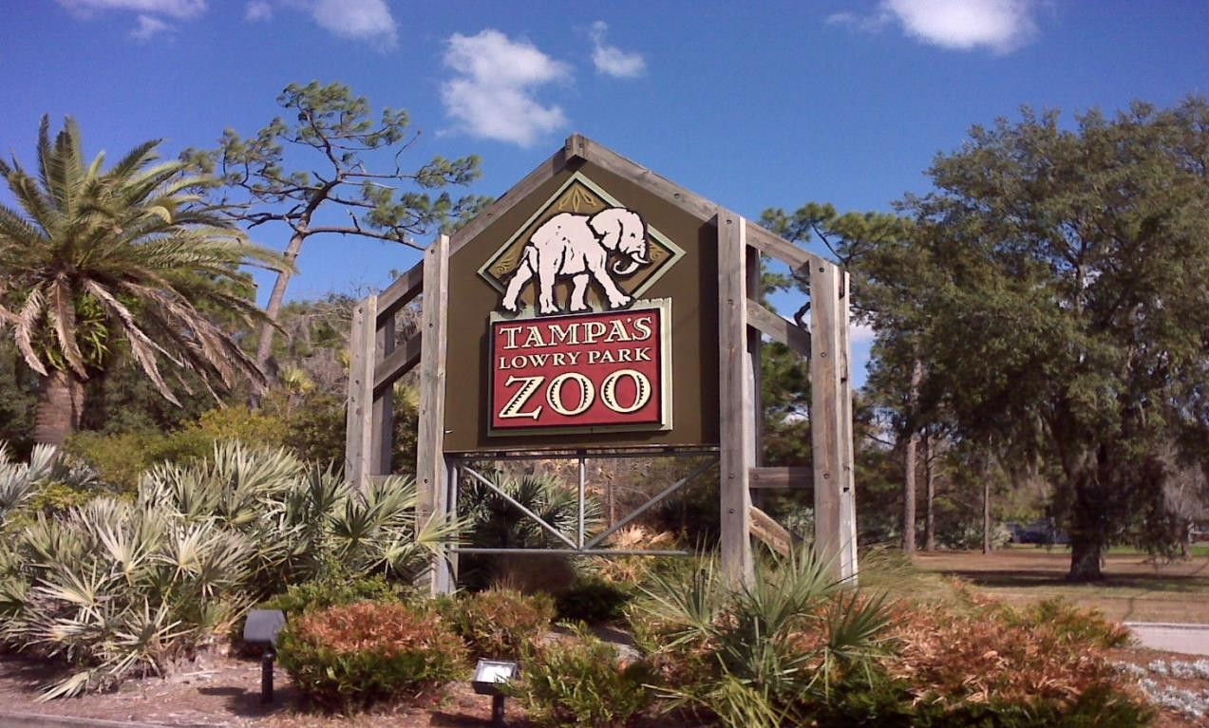

Reasonable Cost of Living
As one would expect, a city with so much to offer like Tampa would be crazily expensive. Paradoxically, compared to other metropolis, Tampa is considered to be among the cities with the lowest cost of living in the US. In fact, Tampa’s cost of living is 3% lower than Florida’s average and below the national average. Housing, utilities, transportation, groceries, healthcare, and miscellaneous good and services, which are the greatest contributors to the cost of living, are fairly affordable.

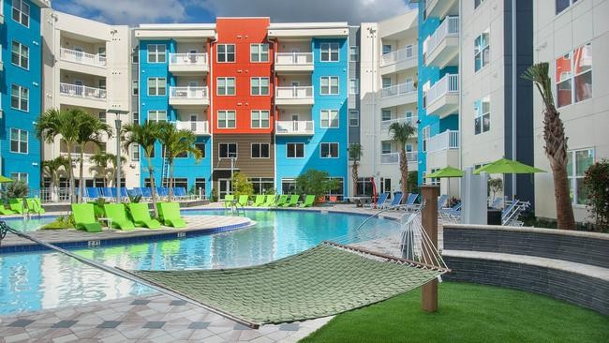

No State Income Taxes
Florida is among the 9 states in the US that do not levy a state income tax. Such a deal, right? For this matter, living in Tampa avails you a beneficial hedge over people living in states where income tax is imposed on earnings. A good reason not to complain that state taxes are eating into all of your earnings and preventing you from taking a vacation to Miami, which is 4 hours away!
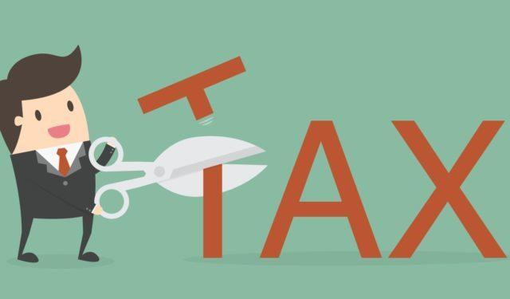

Top Notch Schools
Tampa is an education haven with high-quality schools at all levels. The University of South Florida and Saint Leo University, which are some of the schools in the Kenya Airlift Program, are based in Tampa. Others include The University of Tampa, Florida college, a good number of reputable community colleges, elementary schools, middle schools, and high schools.
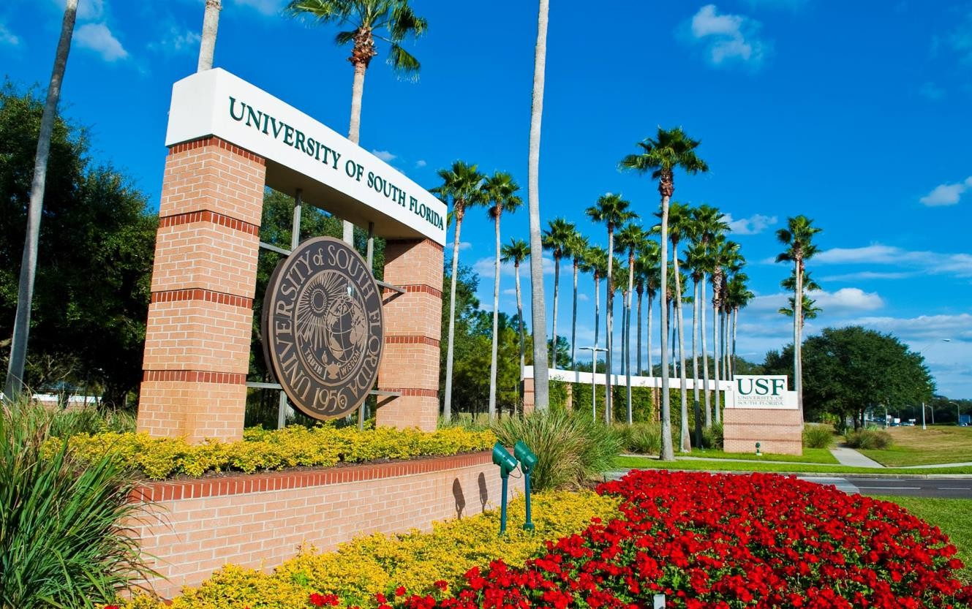

A Growing Community of Kenyan Professionals
Over the last few decades, Tampa has endured a burgeoning interest from Kenyans living in the US, which was not the case before. Equally, in the next few years, with many students who came to study masters in the US under the Kenya Airlift Program graduating, Tampa will be home to many of them as they start their corporate journey. The city is increasingly becoming a perfect home to a growing community of Kenyan professionals working in different jobs in the state. A good reason to feel at home!
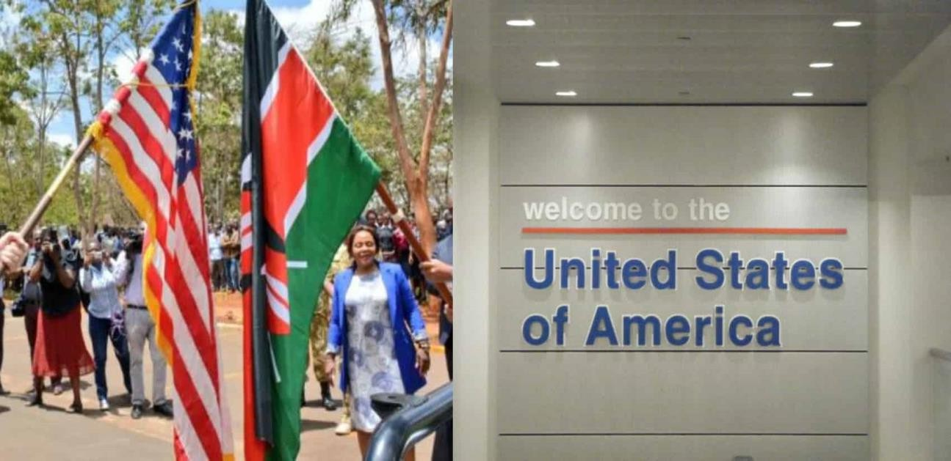

OUR LOCATION AND CONTACT DETAILS

Wells Fargo Center.

100 S. Ashley Drive, Suite 600, Tampa, FL, 33602

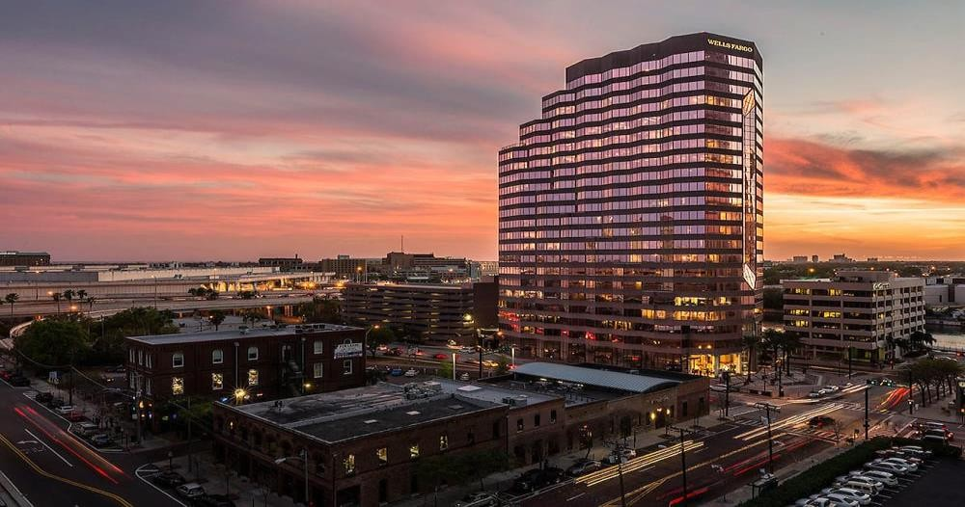
Tel: +1 (813) 573 5619

